Test Case: tc001_SPX_Dev5_Crear_Nueva_Linea_Requisicion_Spot_Tipo_Cobro_CC
Step 1 - Enter username and password and click to button Enter : Credentials Entered
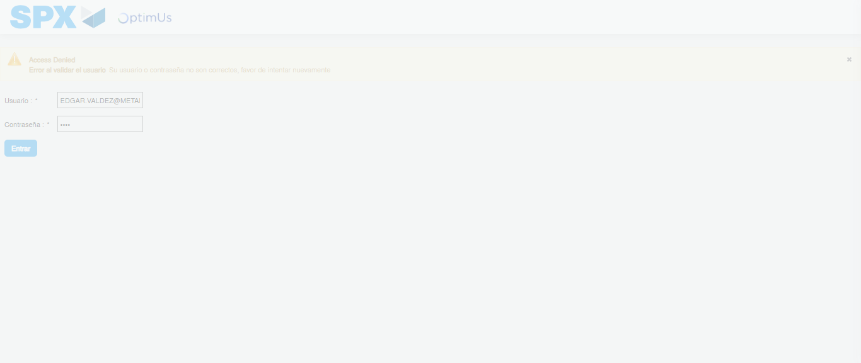Image file-name: QC_Testing-tc001_SPX_Dev5_Crear_Nueva_Linea_Requisicion_Spot_Tipo_Cobro_CC-1781563596792

Step 2 - Select to UEN and Access to Spot Buy Requisitions : UEN Correctly selected and Correct access
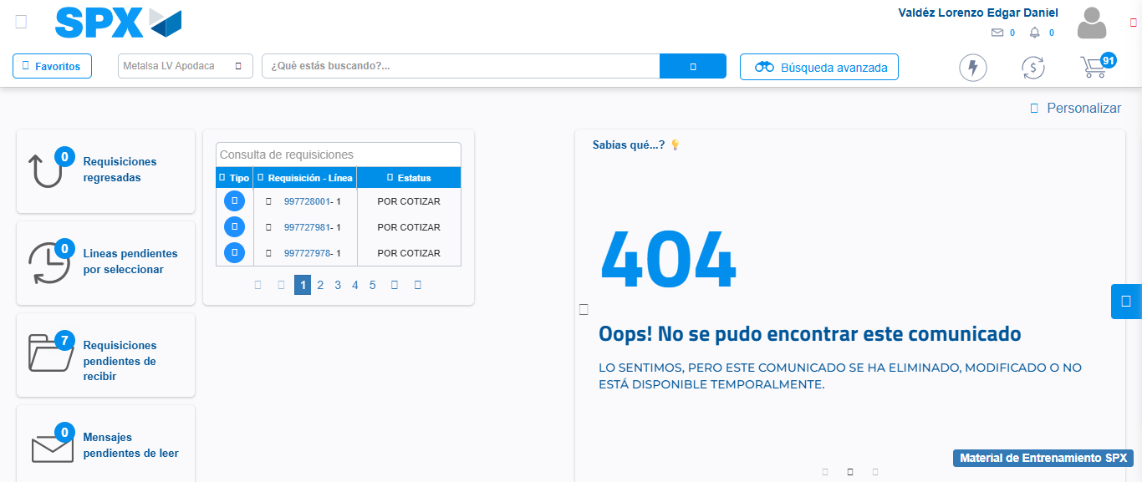Image file-name: QC_Testing-tc001_SPX_Dev5_Crear_Nueva_Linea_Requisicion_Spot_Tipo_Cobro_CC-1781563623742

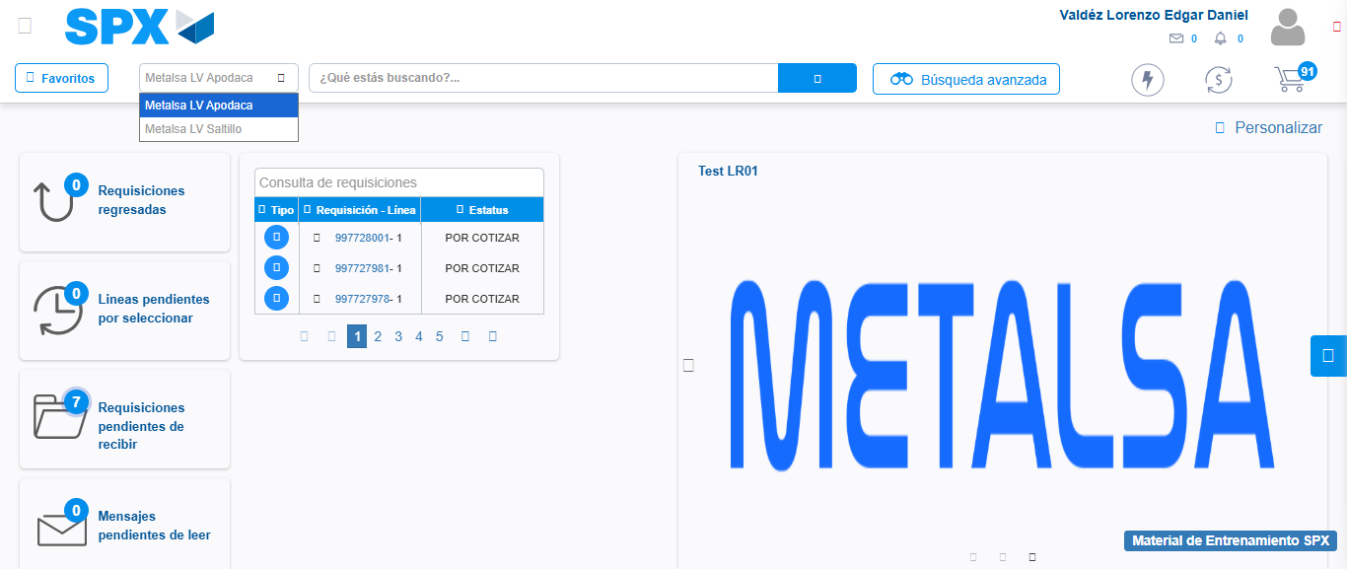Image file-name: QC_Testing-tc001_SPX_Dev5_Crear_Nueva_Linea_Requisicion_Spot_Tipo_Cobro_CC-1781563626262

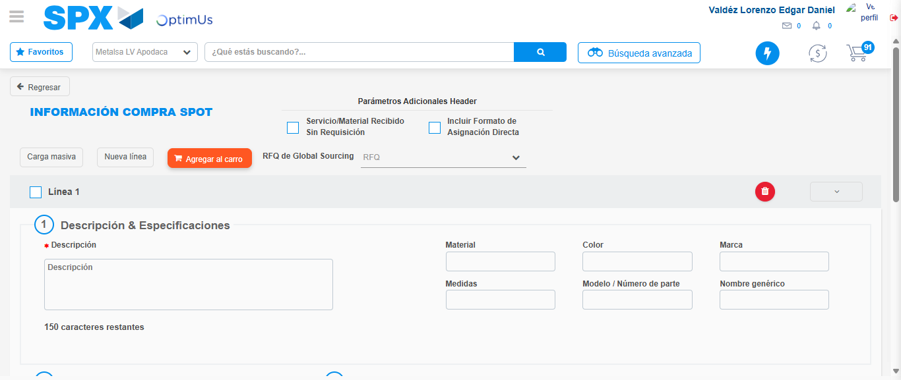Image file-name: QC_Testing-tc001_SPX_Dev5_Crear_Nueva_Linea_Requisicion_Spot_Tipo_Cobro_CC-1781563646553

Step 3 - Data Capture Spot Buy Requisition: Data captured correctly
Image file-name: QC_Testing-tc001_SPX_Dev5_Crear_Nueva_Linea_Requisicion_Spot_Tipo_Cobro_CC-1781563646784

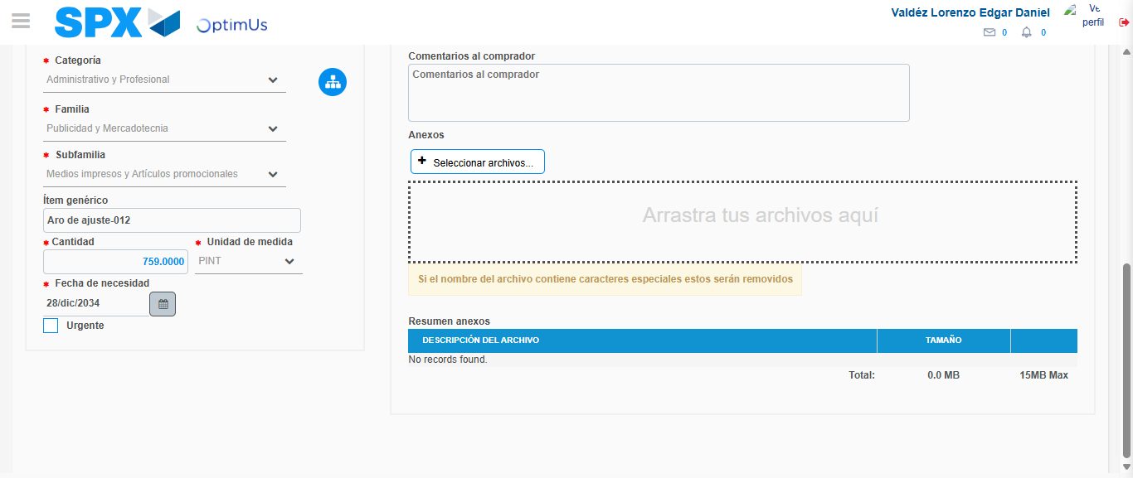Image file-name: QC_Testing-tc001_SPX_Dev5_Crear_Nueva_Linea_Requisicion_Spot_Tipo_Cobro_CC-1781563658210

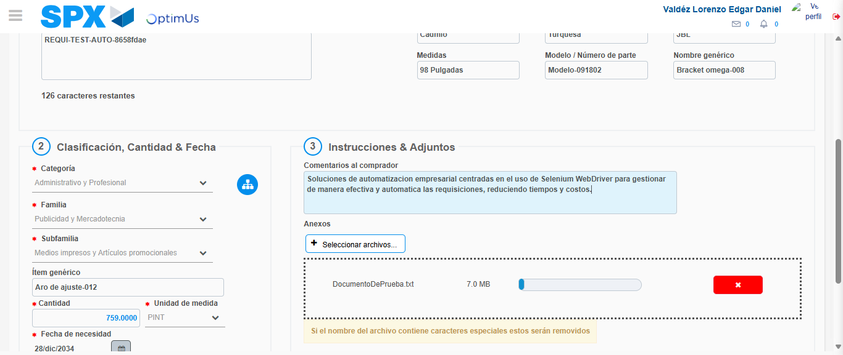Image file-name: QC_Testing-tc001_SPX_Dev5_Crear_Nueva_Linea_Requisicion_Spot_Tipo_Cobro_CC-1781563659013

Step 4 - Add new line and data capture second line: Line add correctly
Image file-name: QC_Testing-tc001_SPX_Dev5_Crear_Nueva_Linea_Requisicion_Spot_Tipo_Cobro_CC-1781563646784

Image file-name: QC_Testing-tc001_SPX_Dev5_Crear_Nueva_Linea_Requisicion_Spot_Tipo_Cobro_CC-1781563658210

Image file-name: QC_Testing-tc001_SPX_Dev5_Crear_Nueva_Linea_Requisicion_Spot_Tipo_Cobro_CC-1781563659013

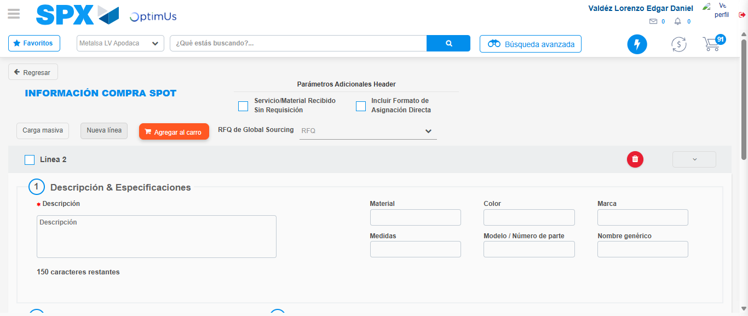Image file-name: QC_Testing-tc001_SPX_Dev5_Crear_Nueva_Linea_Requisicion_Spot_Tipo_Cobro_CC-1781563661345

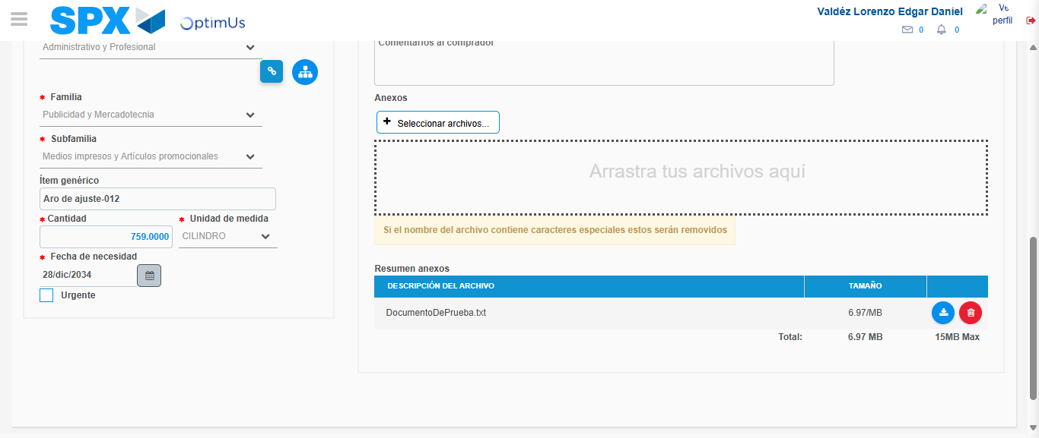Image file-name: QC_Testing-tc001_SPX_Dev5_Crear_Nueva_Linea_Requisicion_Spot_Tipo_Cobro_CC-1781563672578

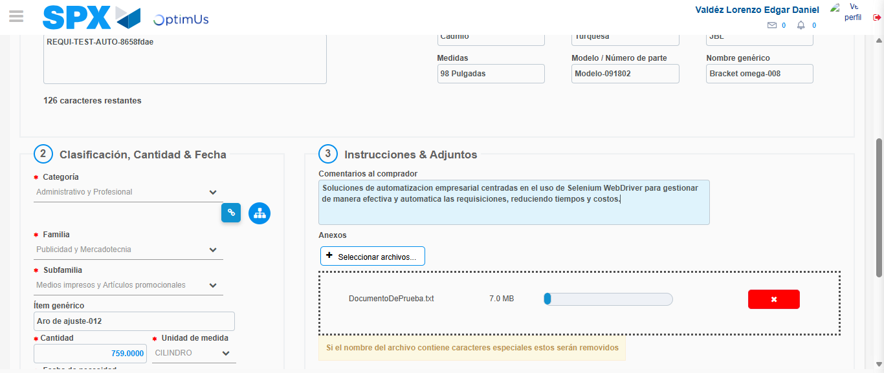Image file-name: QC_Testing-tc001_SPX_Dev5_Crear_Nueva_Linea_Requisicion_Spot_Tipo_Cobro_CC-1781563673347

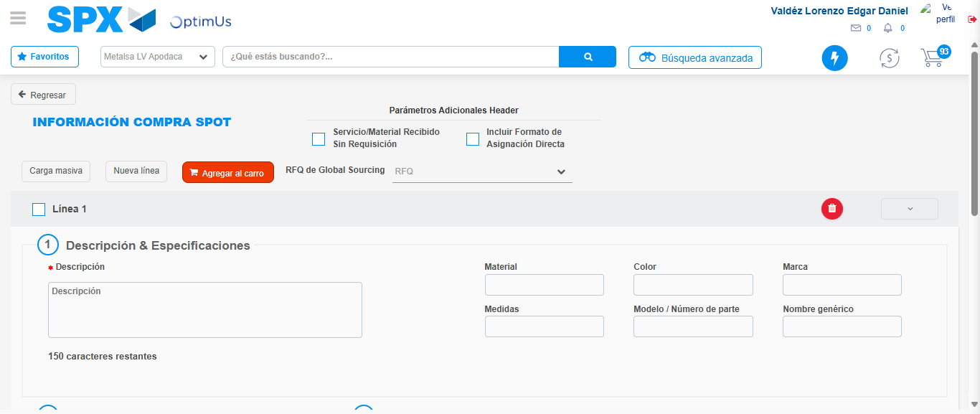Image file-name: QC_Testing-tc001_SPX_Dev5_Crear_Nueva_Linea_Requisicion_Spot_Tipo_Cobro_CC-1781563681417

Step 5 - Select to Requisition: Requisition Correctly selected
Image file-name: QC_Testing-tc001_SPX_Dev5_Crear_Nueva_Linea_Requisicion_Spot_Tipo_Cobro_CC-1781563681618

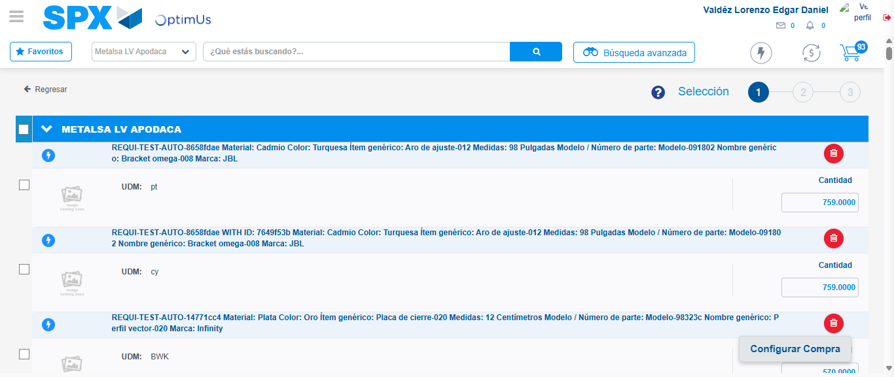Image file-name: QC_Testing-tc001_SPX_Dev5_Crear_Nueva_Linea_Requisicion_Spot_Tipo_Cobro_CC-1781563691665

Image file-name: QC_Testing-tc001_SPX_Dev5_Crear_Nueva_Linea_Requisicion_Spot_Tipo_Cobro_CC-1781563691920

Image file-name: QC_Testing-tc001_SPX_Dev5_Crear_Nueva_Linea_Requisicion_Spot_Tipo_Cobro_CC-1781563692104

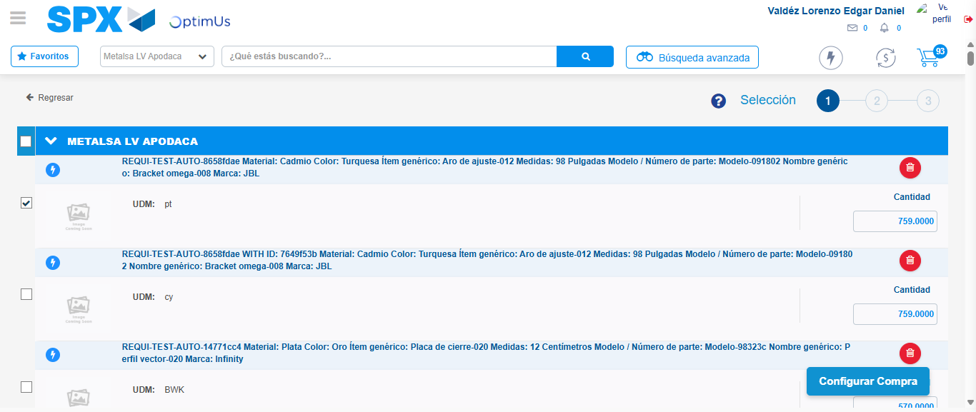Image file-name: QC_Testing-tc001_SPX_Dev5_Crear_Nueva_Linea_Requisicion_Spot_Tipo_Cobro_CC-1781563693544

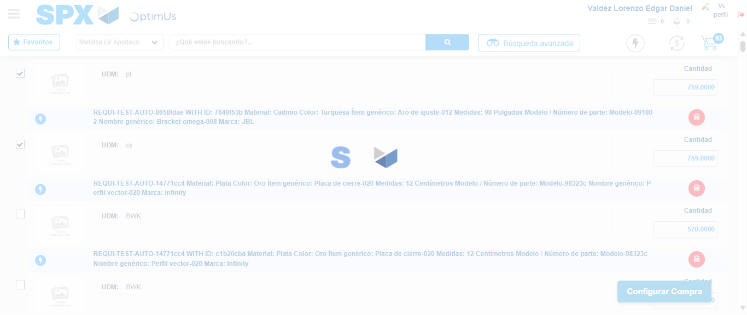Image file-name: QC_Testing-tc001_SPX_Dev5_Crear_Nueva_Linea_Requisicion_Spot_Tipo_Cobro_CC-1781563694521

Step 6 - Select Type Account For Requisition: Type Account Correctly selected
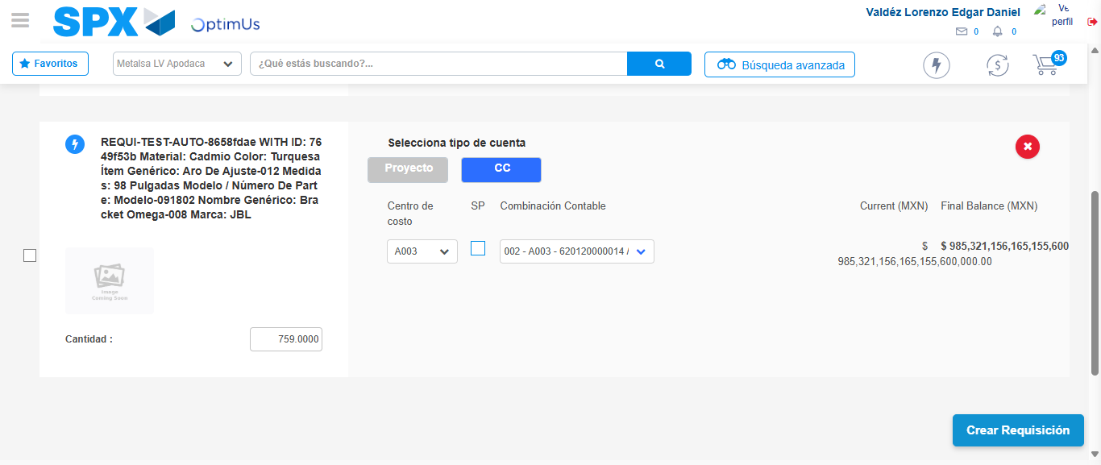Image file-name: QC_Testing-tc001_SPX_Dev5_Crear_Nueva_Linea_Requisicion_Spot_Tipo_Cobro_CC-1781563778194

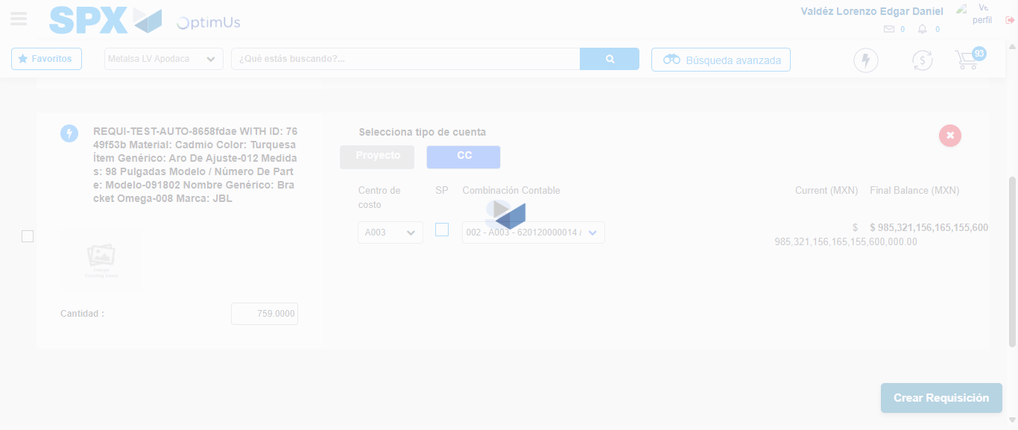Image file-name: QC_Testing-tc001_SPX_Dev5_Crear_Nueva_Linea_Requisicion_Spot_Tipo_Cobro_CC-1781563778570

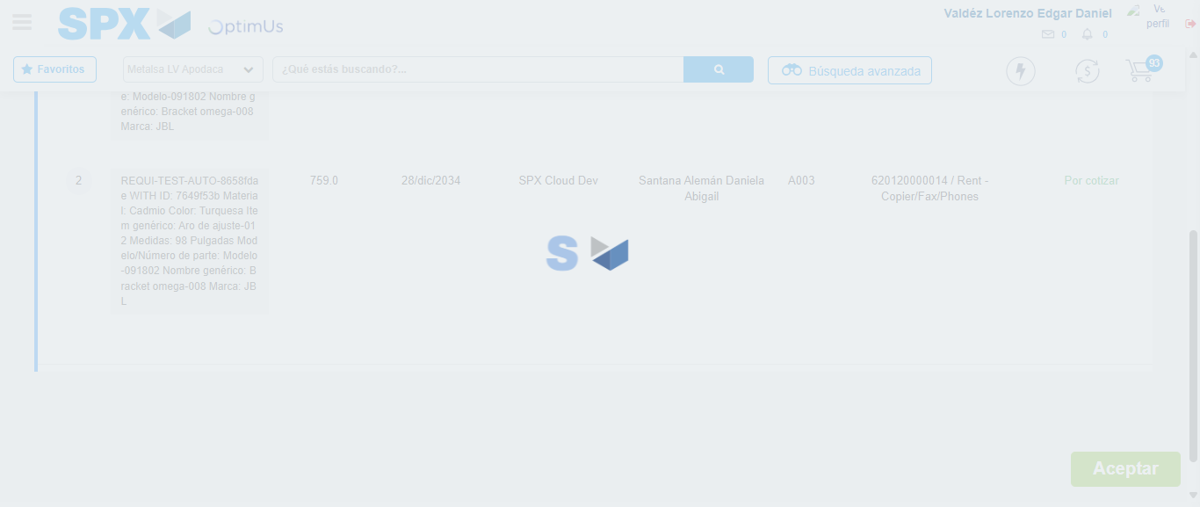Image file-name: QC_Testing-tc001_SPX_Dev5_Crear_Nueva_Linea_Requisicion_Spot_Tipo_Cobro_CC-1781563778780

Step 7 - Accept to Requisition: Requisition Accepted
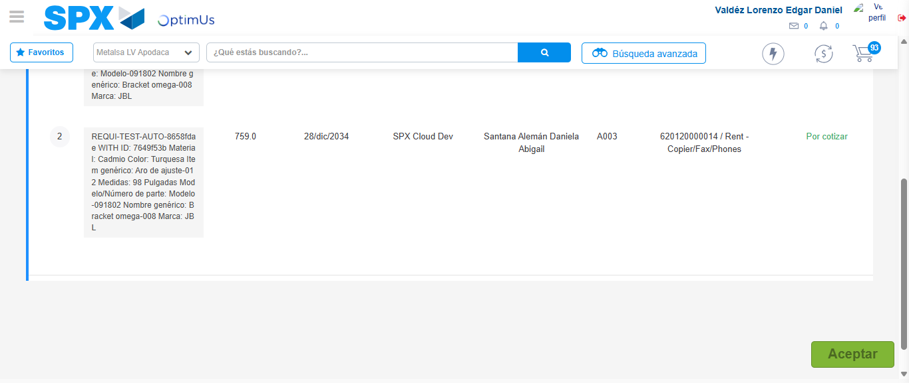Image file-name: QC_Testing-tc001_SPX_Dev5_Crear_Nueva_Linea_Requisicion_Spot_Tipo_Cobro_CC-1781563779566

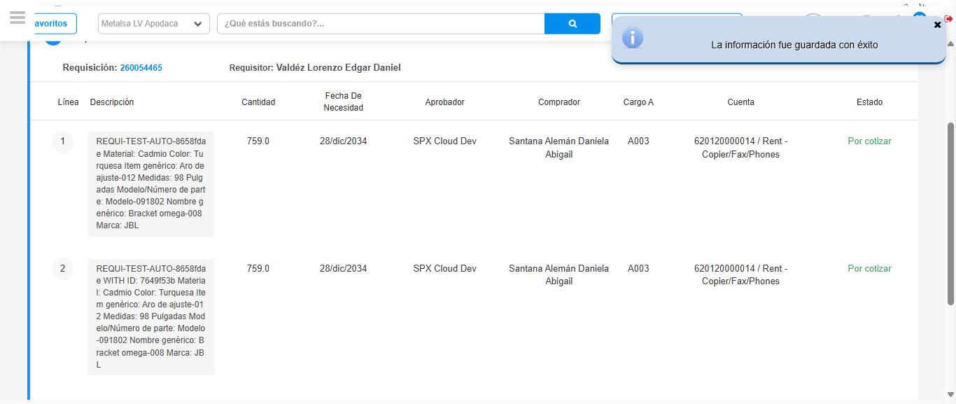Image file-name: QC_Testing-tc001_SPX_Dev5_Crear_Nueva_Linea_Requisicion_Spot_Tipo_Cobro_CC-1781563782033

Step 8 - Return to Main Page SPX : Return to Main Page SPX
Image file-name: QC_Testing-tc001_SPX_Dev5_Crear_Nueva_Linea_Requisicion_Spot_Tipo_Cobro_CC-1781563623742

Image file-name: QC_Testing-tc001_SPX_Dev5_Crear_Nueva_Linea_Requisicion_Spot_Tipo_Cobro_CC-1781563626262

Image file-name: QC_Testing-tc001_SPX_Dev5_Crear_Nueva_Linea_Requisicion_Spot_Tipo_Cobro_CC-1781563646553

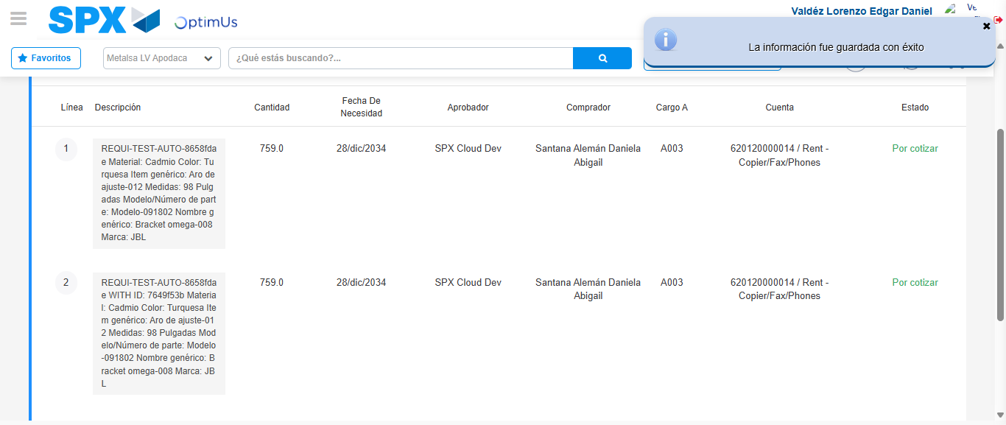Image file-name: QC_Testing-tc001_SPX_Dev5_Crear_Nueva_Linea_Requisicion_Spot_Tipo_Cobro_CC-1781563784282

Image file-name: QC_Testing-tc001_SPX_Dev5_Crear_Nueva_Linea_Requisicion_Spot_Tipo_Cobro_CC-1781563784453

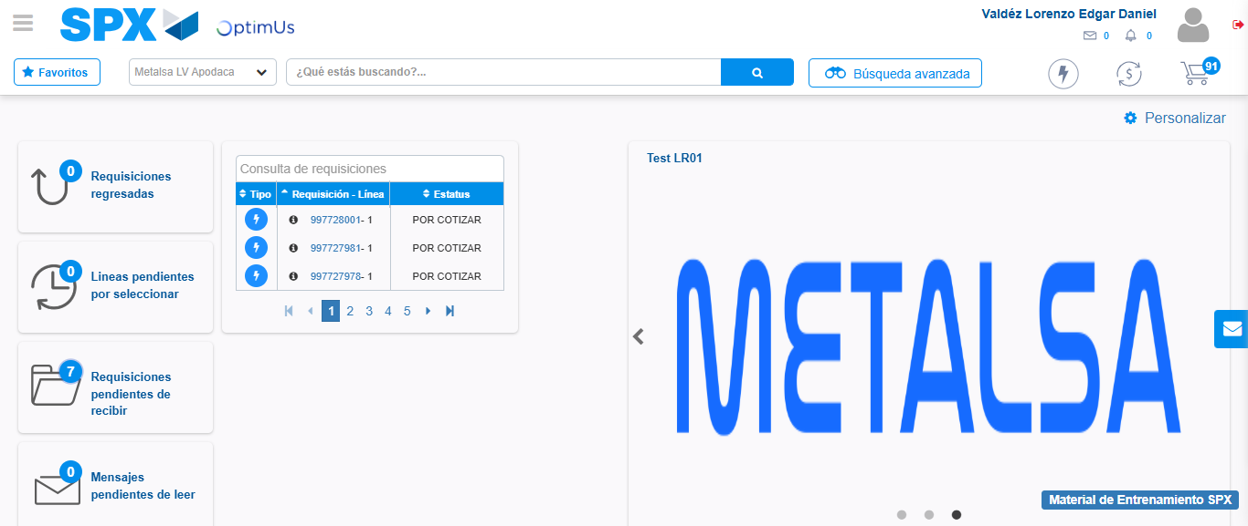Image file-name: QC_Testing-tc001_SPX_Dev5_Crear_Nueva_Linea_Requisicion_Spot_Tipo_Cobro_CC-1781563805608

Step 9 - Log Out : Log Out SPX
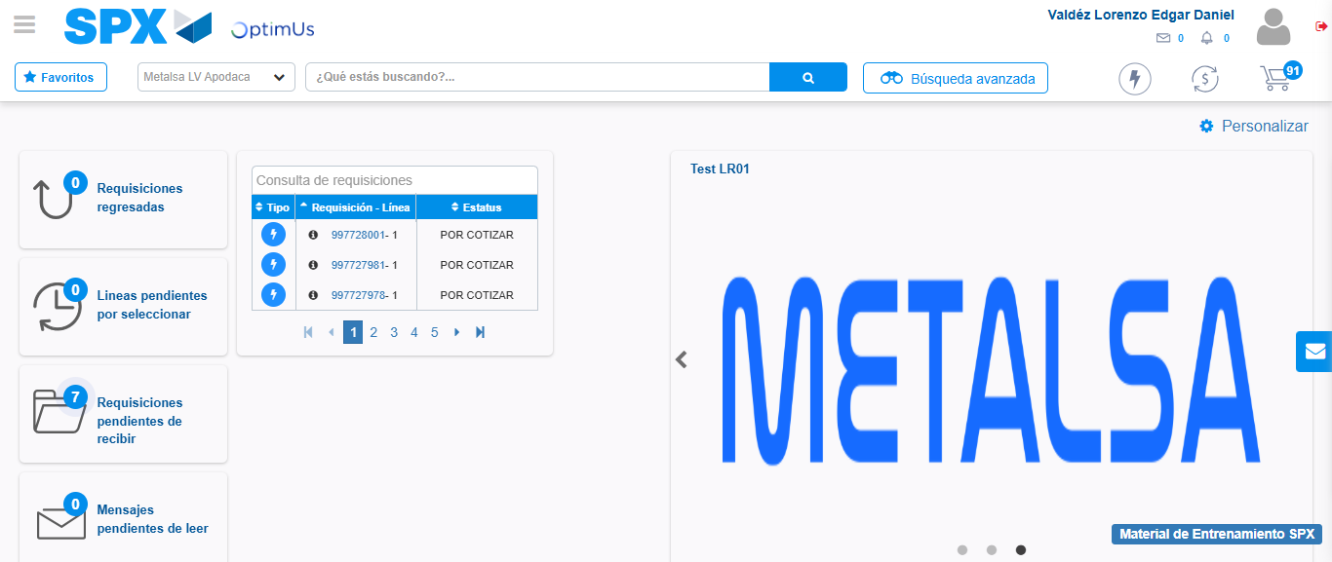Image file-name: QC_Testing-tc001_SPX_Dev5_Crear_Nueva_Linea_Requisicion_Spot_Tipo_Cobro_CC-1781563805857

